

User Manual

for The Recipe

ELEC1005 - Group2

May 2024

# 

# ➕Table of Contents➕

**Introduction & Background 2**

**Get Started and Sign in! 3**

Download your App and press ‘Start’ 3

Sign up and Log in 3

**Main Features 4**

Browse the menu 4

Add or delete recipe to the shopping list 4

**Add a personal style 5**

Filtering and Favoriting your recipes 5

Home page and profile navigation 5

**Simplify your Daily Recipe 6**

Servings Adjustment & Shopping list Generation 6

**Contact our Support Team 7**

# 

# 

# Introduction & Background

Recipe is a mobile application specifically designed for individuals living alone, aiming to optimise their grocery purchases and minimise food waste. This aligns with broader environmental goals, such as reducing the impact of global warming.

In a retail environment predominantly oriented towards family-sized portions, it can be challenging for solo dwellers to shop without exceeding their needs. Recipe addresses this issue by providing a comprehensive platform that allows users to search and filter recipes and automatically generate shopping lists tailored to their exact requirements. Whether planning meals for a day, a week or based on specific dietary needs, Recipe simplifies the shopping process, ensuring that users purchase only what they need.

Additionally, Recipe recommends recipes with overlapping ingredients to allow for bulk purchasing, which is more economical and environmentally friendly than buying small quantities of varied items. It also integrates web-sourced cooking steps, giving users the flexibility to follow the guide that best suits their cooking style.

By focusing on the freshness and variety of ingredients, Recipe enhances the quality of life and wellness for those living alone, making it easier for them to enjoy a healthy and sustainable lifestyle.

1. Minimise Food Waste
2. Economica and Environmental Benefits
3. Enhance Quality of Life

# 

# Get Started and Sign in!

### Download your App and press ‘Start’

To fully enjoy all the features of Recipe, you'll need to create an account. This simple process not only allows you to save your favourite recipes for quick access but also lets you personalise settings and sync your data across all your devices for a seamless experience. The Recipe is available for both iOS and Android devices. You can download it from the Apple App Store or Google Play Store.

### Sign up and Log in

To make the most of The Recipe you'll need to create an account. This allows you to save your favourite recipes, personalise your settings, and sync your data across devices. Simply open the app and follow the on-screen instructions to sign up.

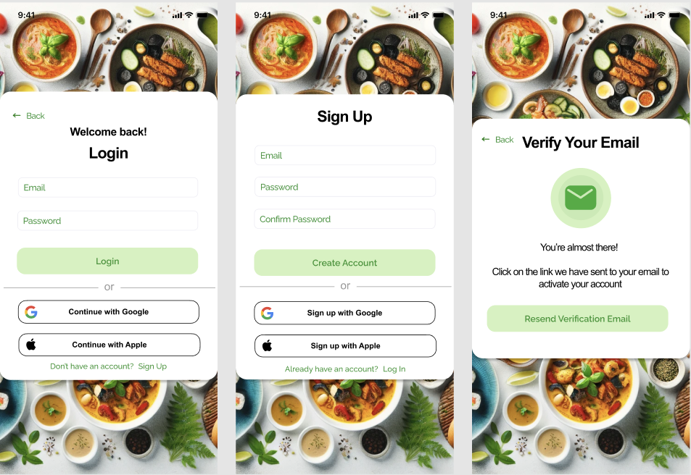

1. Open the app: Download the Recipe

from the Apple App Store or

Google Play Store and launch it.

1. Use your Google or Apple account:

For a quick and secure setup, you can

sign in using your existing Google

or Apple account.

# 

# Main Features

### Browse the menu

After successfully logging in to the menu page, you can browse the menu which includes various kinds of recipe in “Browse” page. As you can see, each cuisine’s block contains the name of the recipe and the preparation time which indicates how much time you will need to cook this dish. Simultaneously, you can amazingly find that above the dishes are different kinds of labels. Therefore, you can just click the label above to filter the recipe for you in different situations. Moreover, there are also recommended recipes which are based on your shopping.

### Add or delete recipe to the shopping list

After browsing the recipe, I bet that you may have decided what kind of recipes you want to shop. Why not try adding them to the shopping list? In the “Browse” page, you can see each recipe has a “+” button next to its name. Simply click on it, and then, go to the “Recipes” page, you can see there are two buttons above—-”My recipe” and “shopping list”. if you click the “My recipe” button. you will amazingly find that the recipe has already been added in your own recipe! Moreover, if you want to make more of that recipe or control the quantity of the recipe. Just click “+” or “-” to add or reduce the amount of it. However, please note that you can only add at most 10 times of one recipe in your shopping list! Meanwhile, if you want to remove the recipe in your shopping list. Just slide the corresponding recipe in “My recipe” and press the “delete” icon in the red colour and it will successfully be removed. Meanwhile when you go to the “shopping list”, you can find the ingredients of each kind of recipe. Just go to the supermarket to buy these ingredients and you can use them to make your own recipe . How convenient!

### Change username & password

If you want to change your account or strengthen the security of the account, then Go to the “Profile” page, click “Show profile”, in this page you can re-enter your username and password . After changing them, you can click “Change username & password” , new username and password are successfully updated. After you click “log out”, you can enter your new username and password you have just set to successfully log in again!

# 

# Add a personal style

### Filtering and Favoriting your recipes

Our team provides you with a small selection of filtering criteria to ensure that your search results align with your expectations and accuracy. Once you search for your recipes, our system will record them and make a list for you to check the history of recipes.

Found a recipe you love? Tap the heart icon to add it to your favorites for easy access later. The more favorite recipes we have means the more we can deliver relevant recipes for you to choose from, which may take the burden of thinking about what to eat off your shoulders!

### Home page and profile navigation

You can customize your profile by setting dietary preferences, allergy information, and frequently used ingredients. This customization affects how recipes are suggested and filtered, ensuring that the app’s recommendations are tailored just for you.

### 

# 

# 

# Simplify your Daily Recipe

### Servings Adjustment & Shopping list Generation

**How to Adjust Servings:**

1. Choose a Recipe: Start by selecting a recipe that you like from our extensive database.
2. Customize Servings: Use the adjustable servings tool to increase or decrease the number of servings. The app automatically recalculates the amount of each ingredient needed.
3. Confirm Changes: Once you've set the desired number of servings, confirm your adjustments. The recipe will update instantly to reflect the new ingredient quantities.

Following the adjustment of servings, the app seamlessly transitions into generating a shopping list for you.

**Generating Your Shopping List:**

1. Automated List Creation: Based on the adjusted recipe ingredients, the app automatically compiles a shopping list. This list includes exact quantities of each ingredient required, helping you buy only what is necessary.
2. Organize by Category: To make your shopping experience even smoother, the list is sorted by categories such as dairy, produce, spices, etc. This categorization helps you navigate through the store efficiently.
3. Check Off Items as You Shop: As you pick up items in the store, you can check them off on your list directly in the app. This ensures you don’t miss anything and prevents the purchase of unnecessary items.

By utilizing the servings adjustment and shopping list generation features, Recipe not only simplifies your meal preparation but also contributes to a sustainable lifestyle by minimizing food waste and unnecessary purchases. This thoughtful integration of features ensures that you spend less time planning and more time enjoying fresh, perfectly portioned meals.

# 

# Contact our Support Team

Here's a section on how users can contact the support team, suitable for inclusion in the Recipe app user manual:

We are committed to ensuring a seamless experience while you use the Recipe app. If you encounter any issues or have questions about how to make the most of the app’s features, our Support Team is here to help.

Here's how you can reach us:

1. **In-App Support:**
   * Navigate to the 'Help' or 'Support' section within the app.
   * Use the built-in messaging feature to send a detailed message directly to our support staff
2. **Email Us:**
   * You can email our support team at wesupport@recipeapp.com.
   * Please include any relevant details or screenshots that might help us understand your issue or query better

Our Support Team is well-equipped and eager to assist you with any inquiries, ensuring that your experience with Recipe is as enjoyable and efficient as possible. Whether you need help adjusting a recipe, navigating the app, or have feedback to share, don't hesitate to reach out.